**Enonce de TP:**

**coron=c(1,0,1,0,0,1,0,0,0,0,0,0,0,1,0,1,0,0,0,1,0,1,1,1,0,1,1,1,0,0,1,0,0,0,0,0,1,1,0,0,0,1,0,0,0,0,0,0,0,1,1,1,0,1,0,0,1,0,1,0,0,0,1,1,0,1,1,0,1,1,0,0,0,1,0,1,1,1,0,0,0,0,0,1,1,0,0,0,0,1,1,1,0,0,0,0,0,1,0,0)**

**hta=c(0,0,1,1,0,0,0,0,0,0,0,0,0,0,0,0,0,0,0,0,0,0,1,0,0,0,0,0,0,1,0,0,0,0,0,0,0,0,0,0,0,0,1,1,0,0,0,1,0,1,1,1,1,1,1,0,1,1,1,0,1,0,0,0,1,0,0,0,0,0,1,0,0,0,0,0,0,0,1,1,0,0,0,1,0,0,1,0,0,1,1,1,1,0,0,0,1,1,1,1)**

**sex=c(1,1,1,1,1,1,1,1,1,1,1,1,1,1,1,1,1,1,1,1,1,1,1,1,1,1,1,1,1,1,1,1,1,1,1,1,1,1,1,1,1,1,0,0,0,0,0,0,0,0,0,0,0,0,0,0,0,1,1,1,1,1,1,1,1,1,1,1,1,1,1,1,1,1,1,1,1,1,1,1,1,1,1,1,1,0,0,0,0,0,0,0,0,0,0,0,0,0,0,0)**

**chol=c(1.25,1.12,1.24,2.19,0.91,1.29,2.28,2.09,1.19,2.78,1.34,1.15,1.93,1.92,0.95,1.25,2.25,1.21,1.24,1.13,1.69,1.96,1.37,1.36,1.07,1.58,1.5,1.71,1.5,1.62,1.65,1.72,1.87,1.35,1.28,1.88,1.73,1.85,1.44,1.39,1.96,1.44,2.19,1.07,1.22,2.31,1.7,2.46,1.87,2.05,1.62,1.61,1.53,1.54,2.06,2.53,0.79,1.25,1.22,1.23,2.21,1.02,1.03,1.24,1.25,1.26,1.43,1.92,2,1.29,0.8,1.22,1.19,1.13,1.57,1.72,1.41,1.07,1.58,2.22,1.05,1.04,1.22,1.22,1.88,2.16,2.14,1.04,2.16,2.11,1.56,1.03,0.23,1.02,1.92,2.28,1.43,1.56,1.85,1.44)**

**y=data.frame(coron,sex,hta,chol)**

**resu<-glm(coron~hta+sex+chol,family=binomial(link=logit),data=y)**

**summary(resu)**

**plot(resu)**

***Execution:***

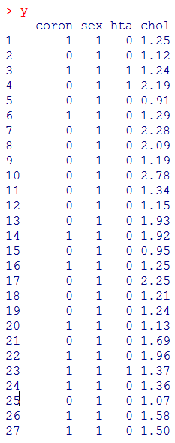 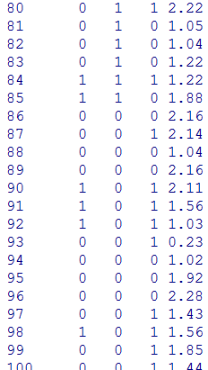 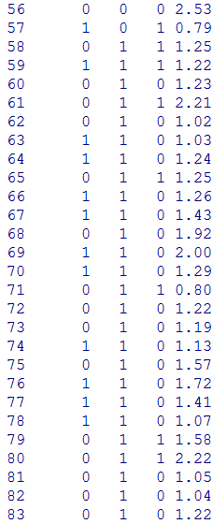 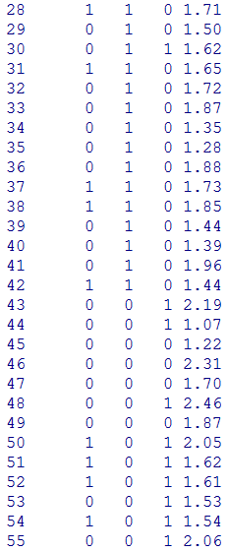

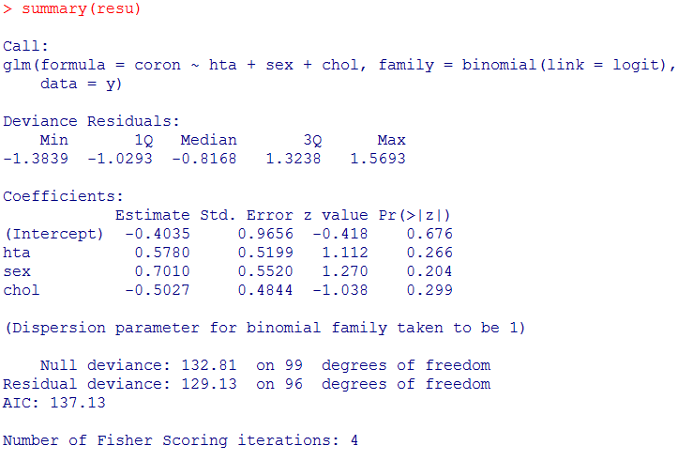

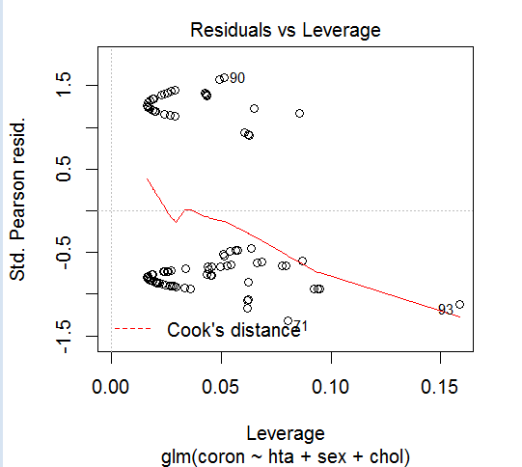 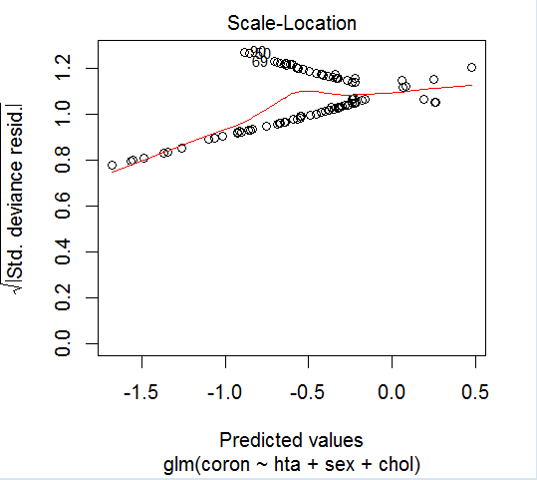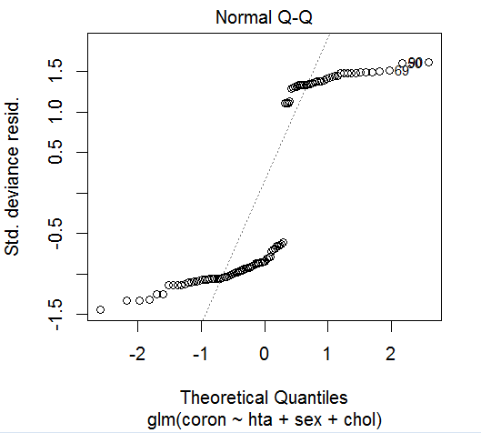 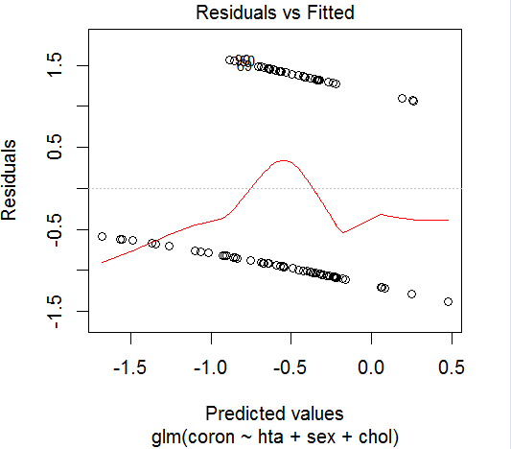

***Interpretation:***

**On a : y=** -0.4035+0.5780**hta**+0.7010**sex**-0.5027**chol**

${OR}_{hta}$**= $e^{0.578}$ = 1.7793 ${OR}_{chol}$ = $e^{-0.5027}$ = 0.6058**

${OR}_{sex}$**= $e^{0.7010}$ = 2.0114**

On a aussi : π $(x_{i})$ = $\frac{\exp^{-0.4035+0.5780hta+0.7010sex-0.5027chol}}{1+\exp^{-0.4035+0.5780hta+0.7010sex-0.5027chol}}$

On a remarquer depuis summary(k) que le Test de Wald nous donne les résultat suivant :

$\frac{β_{hta}}{δ(β_{hta})}$ = 1.112 , $\frac{β_{sex}}{δ(β_{sex})}$ =1.270 , $\frac{β_{chol}}{δ(β_{chol})}$ = -1.038

Et que la deviance égal : D($m_{0}$)=132.81 D($m_{1})$ =129.13 où :

$m_{0}$ = -0.4035 $m_{1}$ =-0.4035+0.5780**hta**+0.7010**sex**-0.5027**chol**

alors : U= D($m_{0}$)- D( $m_{1})$ =132.81-129.13 = 3.68 ~ $x_{96}^{2}$

D’où : au niveau de signification α = 0.20 ,on a remarquer que le **sex** et **hta** faisent une signification à la maladie du "coronarienne" à cause de ( ${OR}_{hta}$**> 1, ${OR}_{sex}$ > 1)** et **Chol** n’est pas significatif car **( ${OR}_{chol}$ ≤ 1) ,** alors le meilleure modèle qui représente la signification à la maladie de coronarienne est**:**

**y= -0.4035+0.5780hta+0.7010sex-0.5027chol**